Basics of Python LO1
14-1-26
Aim – Use print, input and arithmetic functions in python to calculate allowances and gross salary as well as calculate simple interest using principal rate of interest and time period.
Theory –
It uses input to get numeric values from the user, and uses type conversion to ensure the data type.
It uses print function to display the calculated result.
We use addition, multiplication and division to calculate the required results.
It helps us show how python can be applied for financial and salary based applications.
A1.
print("Please enter your basic salary: ", end="")
basic_salary = float(input())
DA = basic_salary * 0.70
TA = basic_salary * 0.30
HRA = basic_salary * 0.10
print("Dearness Allowance (DA): " + str(DA))
print("Travel Allowance (TA): " + str(TA))
print("House Rent Allowance (HRA): " + str(HRA))
print("Gross Salary: " + str(basic_salary + DA + TA + HRA)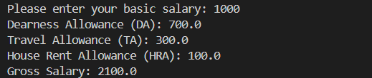
A2.
print("Enter principal amount:", end=" ")
P = float(input())
print("Enter rate of interest (in %):", end=" ")
R = float(input())
print("Enter time period (in years):", end=" ")
T = float(input())
SI = (P * R * T) / 100
print("Simple Interest is: " + str(SI))
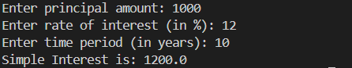
Conclusion
It shows us how the program calculates gross salary and simple interest and how to effectively use input and output as well as type casting in python. It is used for understanding basic financial computations.

